# Appendix 02:

**Some rules for checking flowcharts in BPMN**

1. **The start and end points must be clearly defined in the flowchart**

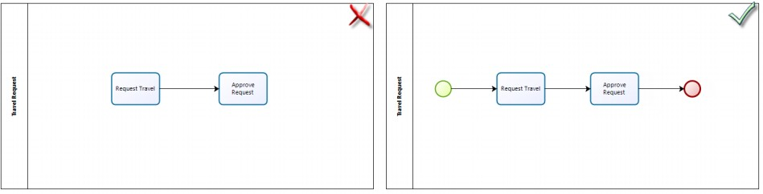

1. 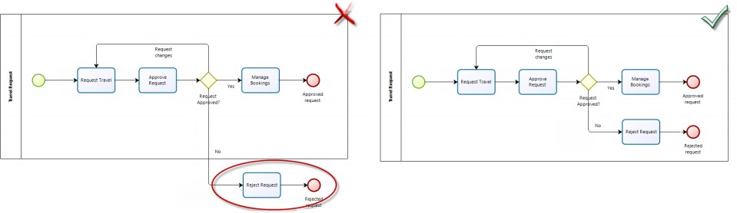**Process flowchart must fit in a Pool**
2. 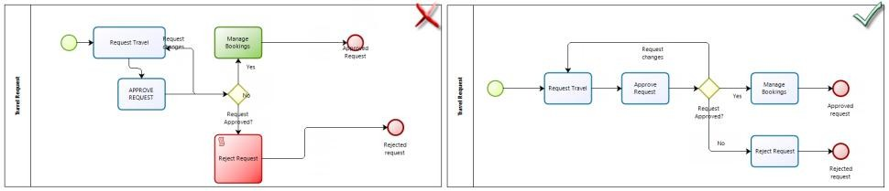**Must use a uniform presentation format among the elements in the flowchart**
3. **Do not leave excess drawing lanes in the Pool**

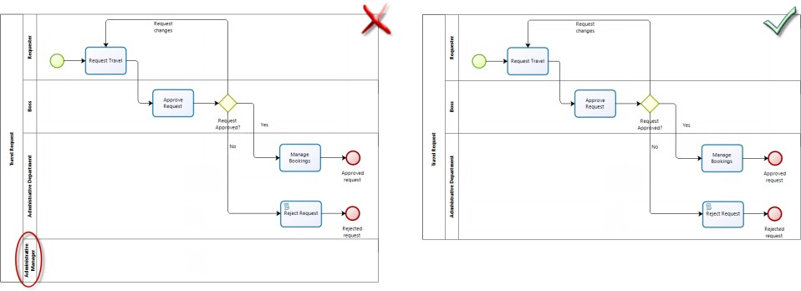

1. 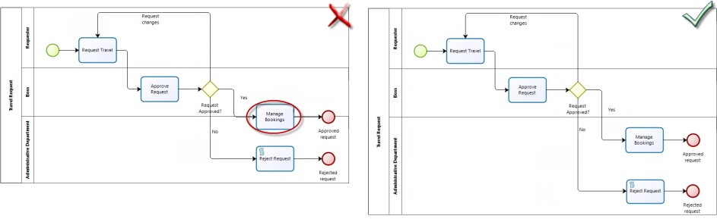**Do not draw activities, branching / branching points, events between lanes**
2. 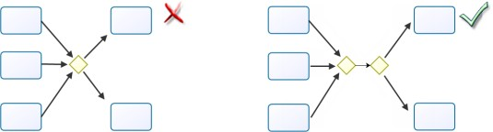**Don't use branching/branching points for both branching and branching**
3. 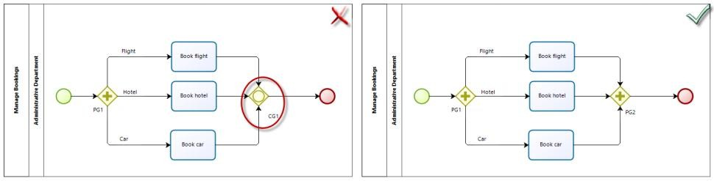**Use the correct type of branching/branching point to branch out**
4. 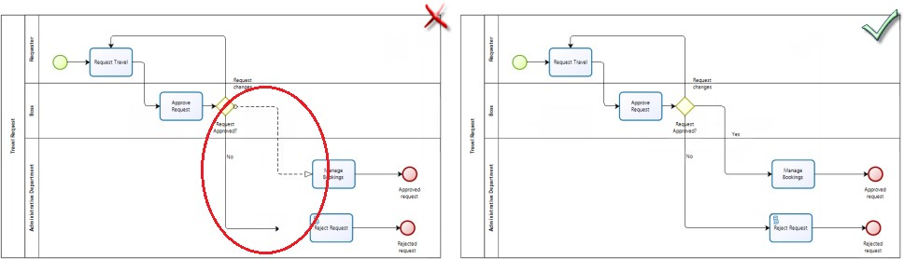**Do not use information connection between components in the same Pool**
5. 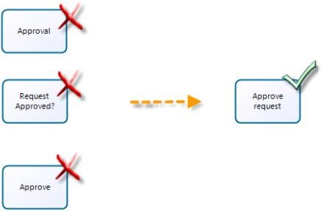**Naming activities with verbs**
6. 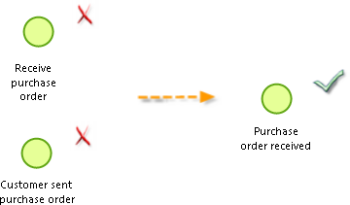**Name the event with a noun**
7. 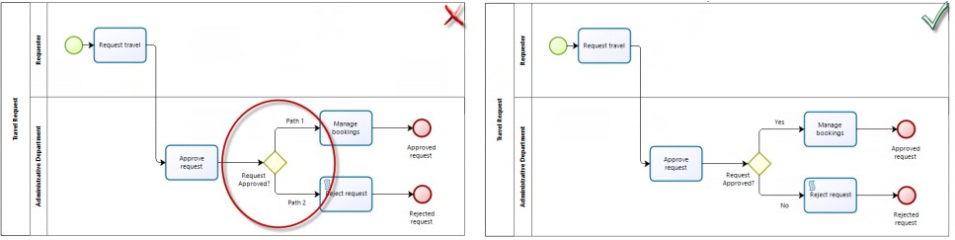**Name the branches out of the exclusion/inclusion point of the branching/exclusion point with the consideration conditions**
8. **More than one person doing the same activity, just draw the activity in the main performer's Lane, then explain more in the detailed description**

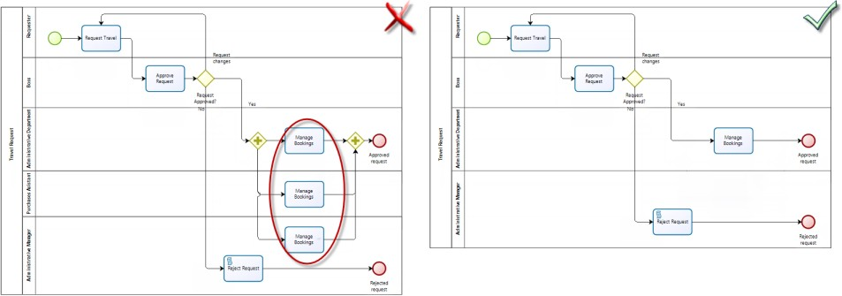

1. **More than one person doing the same activity, just draw the activity in the main performer's Lane, then explain more in the detailed description**



1. 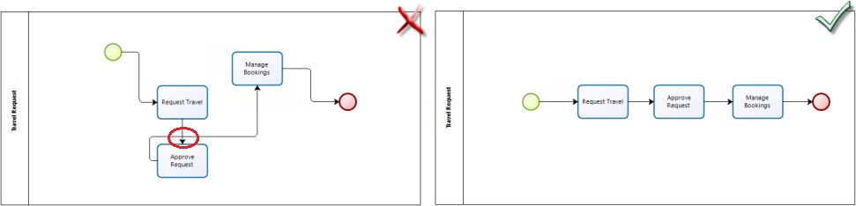**It is advisable to avoid drawing intersecting connection lines**
2. **The flowchart should be drawn in the direction of view from left to right, from top to bottom**

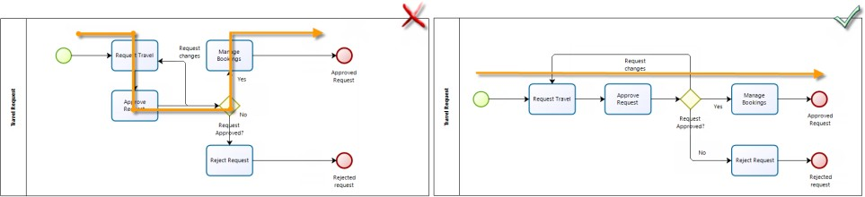

1. **The end event of the exception process flow should be drawn distinct from the main thread**

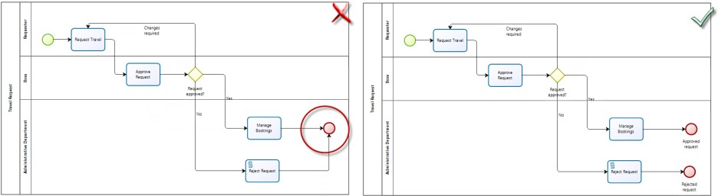

1. **Should draw flowchart in Pool**

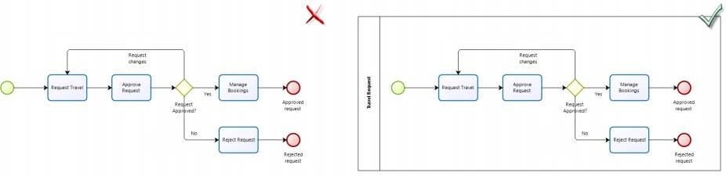

1. **It is always recommended to use branching/joining points for branching**

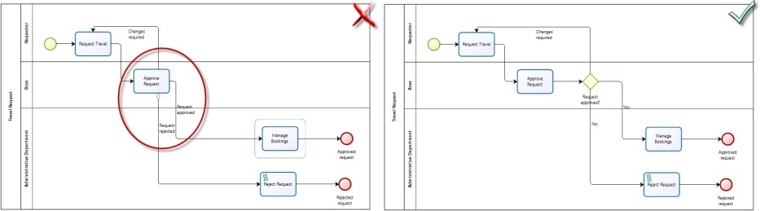

1. 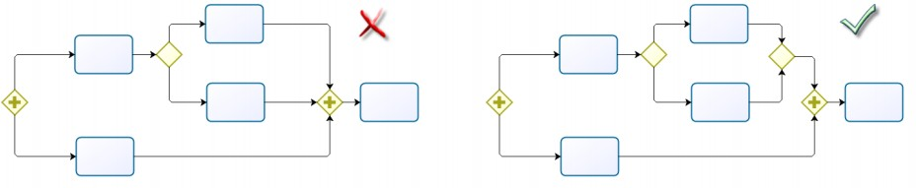**It is recommended to use the rule of “balance gate way”**
2. **The start-end event should not be named “Start Process”, “End Process”**

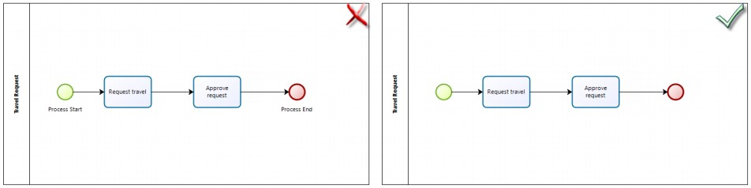

1. **The gateway point should be named and included when branching with the question so that the reader knows what the consideration conditions are..**

